University of California, Merced
Homecoming Tournament
NBA 2K20

General Information
- All participants must join the UC Merced Homecoming E-Sports Tournament Discord Server as this will be the main means of communication among tournament admins and participants.

Game Time: Each tournament round will be allotted 48 hours to complete the matchup and submit results on the discord server.
- It is each captain’s responsibility to contact the opponent via discord to schedule the time to play.
- If scores are not submitted by matchup deadline, a double forfeit will be assessed.

Scheduling:
- Contact information and gamertags are to be input into the UC Merced Homecoming E-Sports Tournament under the ‘2K20 – xbox-general or ps4-general’ channel text chat.
  - 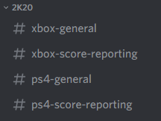

Reporting Game Results- When a match has been completed, the winning team’s captains should send the result listing the name and the match score to the ‘2K20 – xbox-score-reporting OR ps4-score-reporting’ channel text chat.
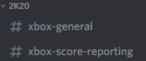 here for Xbox One OR
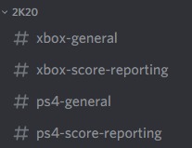 here for Playstation 4

Equipment
1. Each participant will need to provide their own equipment to play in this esports league/tournament. Xbox One and PS4 divisions available

Format
- Single Elimination tournament with each round allowing a 48-hour window to complete match-up.
- Contact information for each player will be available in the ‘2K20 – (xbox/ps4)-general’ channel text chat.
- The results of each match are to be posted in the Discord ‘2K20 – (xbox/ps4)-score-reporting’ channel text chat. Make sure that the winner’s name, loser’s name, and the scores are all listed in the message. Once scores are received, the winning team will be advanced in the bracket.

Sport Specific Rules
- Match length: All matches will be Best of 1 game.
- The assigned home team will create the game lobby.
- The assigned away team will have a choice of jersey color.
- The game settings should be set to the following:
  - Quarter Length: 5 minutes
  - Skill Level: Hall of Fame
  - Injuries: Off
  - Game Style: Default
  - Game Mode: VS
  - Camera Setting: 2K Standard
  - Participants are allowed to select any of the current NBA franchises to play with
  - Participants are allowed to select any starting lineup within the team they chose
  - All-star/ rising star/ past teams are not allowed to be played with
  - No physical or rating adjustments allowed to any players.
- Free Throws: When a player is shooting a free throw, the defensive player cannot pause the game until their team gets the rebound off of the free throw.
- Pauses: If a team’s pause timer runs out that team will forfeit the game.
- If a glitch/ freeze occurs in the system the game will be completely restarted with the same settings (ie. teams).
  - Any attempt to make the game glitch/ freeze wll result in an automatic forfeit from the game (Throwing controller, excessively pausing and starting the game, etc.)
- If you believe that your opponent is cheating by abusing game programming glitches to gain advantage or is violating the parameters set by the Homecoming E-Sport Staff, report it immediately.

